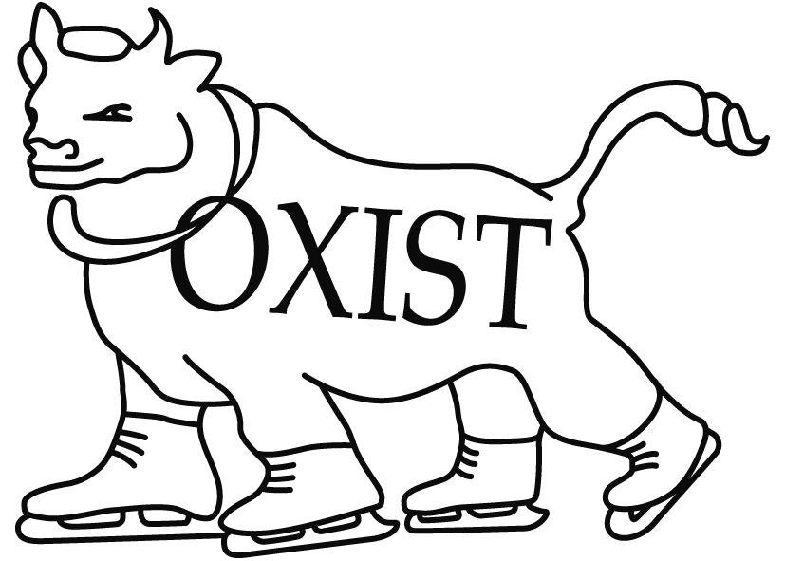

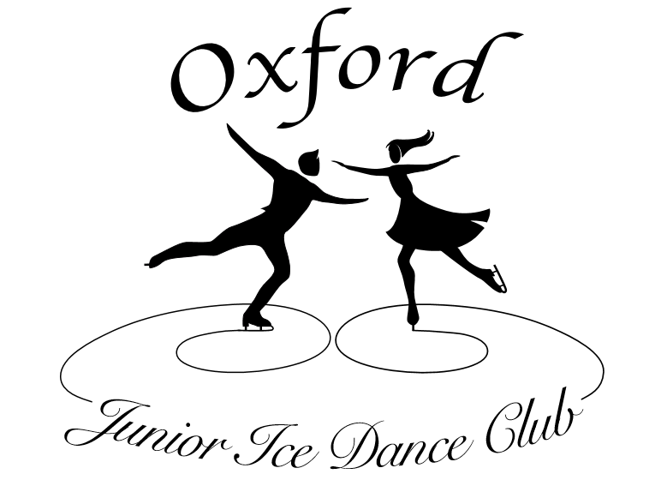

OXIST/Oxford Junior & Senior Ice Dance Clubs
CLUB COMPETITION
Sunday 25th June 2017 5.30-8.30 pm

Closing date: 4th June 2017

Section A - Solo Pattern Dance
ISU pattern dance music will be provided by the organisers for all categories except Basic Novice and Advanced Novice, where skaters may provide their own music.
Class 1 Beginner
Competitors may not hold the Level 1 Pattern Dance Test, and may not have skated in an open dance competition.
Novice (Preliminary) Foxtrot – 1 full circuit of the rink.
Class 2 Level 1
Competitors may not hold the Level 2 Pattern Dance Test.
Canasta Tango – 2 sequences.
Class 3 Level 2/3
Competitors may not hold the Level 4 Pattern Dance Test.
Golden Skaters Waltz – 2 sequences.
Class 4 Level 2-4
Competitors may not hold the Level 5 Pattern Dance Test.
Fiesta Tango – 2 sequences.
Class 5 Juvenile
22 Step – 2 sequences
Class 6 Primary
Foxtrot – 4 sequences
Class 7 Basic Novice
Either American Waltz (2 sequences) or Blues (3 sequences). The dance will be selected when the dances drawn for the Solo Dance Championships are known, and will be one of the drawn dances.
Skaters may provide their own music.
Class 8 Advanced Novice
One of Rocker Foxtrot (4 sequences), or Tango (2 sequences). The dance will be selected when the dances drawn for the Solo Dance Championships are known, and will be one of the drawn dances.
Skaters may provide their own music.

Section B - Solo Short Dance
Entrants in the Short Dance category should submit a planned programme content sheet with their entry.
Class 9 Solo Short Dance Junior

Blues plus any number of the following Rhythms: Swing, Hip Hop.

Rules and Rhythm as per ISU communications 1998 / 2003 and any pertinent updates (see www.isu.org).
The Pattern Dance Elements must be skated on the Blues Rhythm. The Tempo of the music throughout the Pattern Dance Element must be constant and in accordance with the required Tempo of the Pattern Dance Blues, i.e. 22 measures of 4 beats or 88 beats per minute, plus or minus 2 beats per minute.
The Step Sequence must be skated on one of the other rhythms e.g. Swing or Hip Hop
Replacing the required elements with,
- Pattern Dance Element: Two sequences of Blues skated either one after another or separately. Step #1 must be skated on different sides of the ice surface.
- 1 (one) Pose/Combination Pose (NB Attitudes are Poses)
- 1 (one) Midline, Diagonal or Circular step sequence. The Level of the Step Sequence shall be given using the Characteristics of Levels Style B
- 1 (one) set of sequential twizzles
A Dance Spin is not a Required Element. Nevertheless a Dance Spin or spinning movement may be skated outside the step sequence on one foot or two with any number of revolutions as part of the chosen choreography. These movements will be ignored by the Technical Panel and the Judging Panel will not consider these movements as one of the permitted stops.
NB. Junior Short Dance. A Dance Spin performed in the Step Sequence shall be considered by the Judges as a Stop, which will be considered as a Not Permitted Element.
For the Junior Short Dance, the Blues, Hip Hop, and Swing Rhythms are described in the ISU Ice Dance Music Rhythms Booklet 1995 and subsequent updates.
Vocal Music is permitted.
Duration of the Short Dance: 2 minutes 50 sec +/- 10 secs.

Section C - Solo Free Dance
Entrants in Free Dance categories should submit a planned programme content sheet with their entry.
Class 10 Solo Free Dance 1.5 minutes
1. 1 (one) Single Pose.
2. 1 (one) Straight Line Step Sequence skated barrier to barrier. The Level of the Step Sequence shall be given using the Characteristics of Levels Style B.
3. 1 (one) Dance Spin with a minimum of 3 revolutions. Combination spins are not permitted.
4. 1 (one) set of Sequential Twizzles with no more than 3 steps between the twizzles.
- Minimum 1x clockwise and 1x anti-clockwise.
- Minimum 1 rotation in each twizzle.
Additional sets of twizzles are permitted, but only the 1st attempted set (outwith the step sequence) will count within the technical score. Others will be considered within the choreography mark
Depending on the number and test/competitive level of the participants, it is anticipated that this category will be split into at least two groups.

Class 11 Solo Free Dance 2 minutes
1. 1 (one) Single Pose.
2. 1 (one) Straight line Step Sequence (barrier to barrier) or 1 (one) Curved Step Sequence covering the full width of the ice. The Level of the Step Sequence shall be given using the Characteristics of Levels Style B.
3. 1 (one) Dance Spin with a minimum of 3 revolutions. Combination spins are not permitted.
4. 1 (one) set of Sequential Twizzles with no more than 3 steps between the twizzles.
- Minimum 1x clockwise and 1x anti-clockwise.
- Minimum 1 rotation in each twizzle.
Additional sets of twizzles are permitted, but only the 1st attempted set (outwith the step sequence) will count within the technical score. Others will be considered within the choreography mark.

Class 12 Solo Free Dance 2.5 minutes
- 1 (one) Combination Pose or 2 (two) Single Poses. No Pose of the same type may be repeated. If performed the Single Poses must be seperated by more than 3 steps between them.
- 1 (one) Straight line Step Sequence (barrier to barrier) or 1 (one) Curved Step Sequence covering the full width of the ice. The Level of the Step Sequence shall be given using the Characteristics of Levels Style B.
- 1 (one) Dance Spin with a minimum of 3 revolutions. Combination spins are not permitted
- 1 (one) set of Sequential Twizzles with no more than 3 steps between the twizzles
- Minimum 1x clockwise and 1x anti-clockwise
- Minimum 1 rotation in each twizzle
Additional sets of twizzles are permitted, but only the 1st attempted set (outwith the step sequence) will count within the technical score. Others will be considered within the choreography mark

Class 13 Solo Free Dance 3 minutes

- 1 (one) Combination Pose or 2 Single Poses. No Pose of the same type may be repeated. If performed, the Single Pose(s) must be seperated by more than 3 steps between them.
- 1 (one) Straight Line Step Sequence (Mid Line or Diagonal) skated barrier to barrier.
- 1 (one) Curved (Circular or Serpentine) Step Sequence utilizing the full width of the ice surface.
- 1 (one) Dance Spin only
- I (one) set of Sequential Twizzles with no more than 3 steps between the twizzles.
- Minimum 1x clockwise and 1x anti-clockwise
- Minimum 1 rotation in each twizzle
Additional sets of twizzles are permitted, but only the 1st attempted set (outwith the step sequence) will count within the technical score. Others will be considered within the choreography mark.
In programs requiring two Step Sequences the Level of the first performed Step Sequence shall be given using the Characteristics of Levels Style A and the second Step Sequence evaluated using the Characteristics of Levels Style B.

Section D - Couples Ice Dance
Class 14 Beginner
Rhythm Blues – 2 sequences
Depending on the level of entries, class 14 may be split by test standard and/or age.
Class 15 Novice
Swing Dance – 2 sequences
Class 16 Intermediate
Fourteenstep – 3 sequences
Class 17 Senior
European Waltz – 2 sequences
RULES FOR THE EVENT
All competitors must be members of OXIST Ice Skating Club, or Oxford Junior or Senior Ice Dance Clubs.
The organising committee reserves the right to refuse any entry without reason assigned.
The organising committee reserves the right to split, combine or cancel any classes as it sees fit.
Competitors may enter a maximum of ONE solo pattern or short dance and ONE solo free dance category. Competitors may also enter ONE couples’ category in addition to any solo categories.
All entries will be marked with date of receipt. In the event of the competition being over-subscribed, the latest received entries will not be accepted, and the entry fee will be returned.
The competition will be judged using closed marking.
Closing dates for entries will be Sunday 4th June 2017. Entries should be given in at the OXIST Desk (Sundays) or posted to the Club Competition Secretary, Fiona Brown, at 22 Bexley Court, Parkside Road, Reading RG30 2DY. The organising committee cannot be held responsible for late or lost entries. If space permits, late entries may be accepted at the discretion of the organising committee, provided that the draw has not taken place.
Only the named person on the entry form (or a parent or guardian for skaters under 18) may cancel their entry. Entry fees cannot be refunded if cancellation is made after the closing date.
The draw for the order of skate will take place after the OXIST Session on 11th June in the Café Area. All competitors are invited to attend. Full running order will be posted on the OXIST website as soon after as possible.
First place winners must sign a receipt for their trophies, which must be returned when requested by the OXIST Club Committee. All sponsored trophies belong to either the OXIST Club or Oxford Ice Dance Club, and are perpetual.
On the day of the competition, all competitors are requested to check in at the Registration Desk by 17.30 or at least half an hour before their class is due to start (whichever is the earlier). Skaters supplying their own pattern dance music, or who have entered a free dance, must hand in their music at this time. PLEASE NOTE: ONLY MUSIC ON CD WILL BE ACCEPTED.
Flash photography is not permitted during the competition or warm-ups. Please do not photograph or video any skater without their or their parent’s/guardian’s prior consent. Please also be aware of Oxford Ice Rink’s Child Protection policy, which requires anyone wishing to take photographs or videos to obtain prior authorisation from the rink.
ENTRY FEES:
Solo skaters - £18.00 per skater for the first class, £15.00 for the second class.
Couples - £25.00.
PLEASE MAKE CHEQUES PAYABLE TO ‘Oxford Ice Dance Club’, or transfer to the following account:
Account Name: Oxford Ice Dance Club
Account Number: 00436396
Sort Code: 30-90-77
Please use the reference CC plus the skater’s name.

PLEASE USE SEPARATE FORMS FOR SOLO AND COUPLES CLASSES
PLEASE FILL OUT USING BLOCK CAPITALS
NAME ......................................................... NAME 2 .............................................……….
(For couples)
ADDRESS ................................................... ADDRESS .......................................…………
.......................................................………… ......................................................…………..
.......................................................………… .......................................................………….
TEL NO ...................................................... TEL NO ..........................................………….
E MAIL ....................................................... E MAIL ...........................................………….
AGE (If under 18) ......................................…. AGE (If under 18) ........................……………
TEST STANDARD (FM) ......................... TEST STANDARD (FM) ..........…………….
TEST STANDARD (PD) .......................... TEST STANDARD (PD) ..........…………….
TEST STANDARD (FD) .......................... TEST STANDARD (FD) ..........…………….
Please enter me/us into the following category/ies
Section A: Solo Pattern Dance |  |  | Section C: Free Dance
 | Beginner (Novice Foxtrot) |  |  | 1.5 minute Free Dance
 | Level 1 (Canasta Tango) |  |  | 2 minute Free Dance
 | Level 2/3 (Golden Skaters Waltz) |  |  | 2.5 minute Free Dance
 | Level 2-4 (Fiesta Tango) |  |  | 3 minute Free Dance
 | Juvenile (22 Step) |  | Section D: Couples Pattern Dance
 | Primary (Foxtrot) |  |  | Beginner (Rhythm Blues)
 | Basic Novice (Blues or American Waltz) |  |  | Novice (Swing Dance)
 | Advanced Novice (Rocker Foxtrot or Tango) |  |  | Intermediate (Fourteenstep)
Section B: Short Dance |  |  |  | Senior (European Waltz)
 | Advanced Novice
Entry fees: £18 per skater for the first solo event, £15 for each additional solo event.
£25 for couples.
I/we agree to the rules of the event. For competitors under 18, a parent or guardian must sign.
SIGNED ....................................................... SIGNED .........................................................
I/we enclose £........................... cash/cheque as payment for the above class(es).
RETURN THIS FORM TO THE OXIST DESK (Sundays), hand it to any committee member, or post it to Fiona Brown, 22 Bexley Court, Parkside Road, Reading RG30 2DY
Name: ………………………………………………..............................................

Short Dance
Elements in order of skating
1
2
3
4
5
6
7
8

Free Dance Length …………
Elements in order of skating
1
2
3
4
5
6
7
8
9
10

