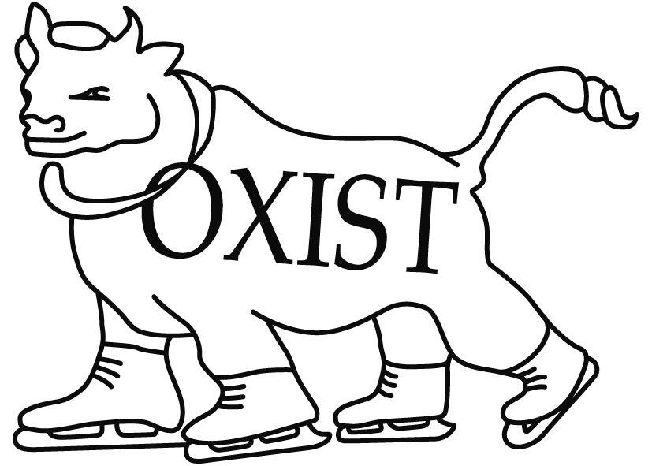

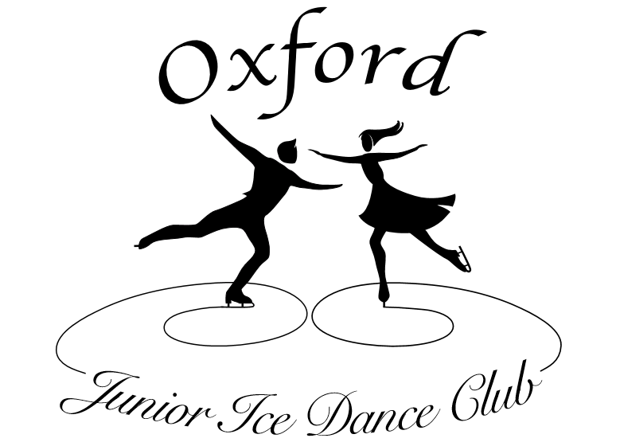

OXIST/Oxford Junior & Senior Ice Dance Clubs
CLUB COMPETITION
Sunday 23rd June 2019 4.30-8.30 pm

Closing date: Tuesday 4th June 2019

Section A - Solo Pattern Dance
Class 1 Beginner (without keypoints)
Competitors may not hold the Level 1 Pattern Dance Test, and may not have skated in an open dance competition.
Novice (Preliminary) Foxtrot – 2 sequences (1 full circuit of the rink).
Class 2 Level 1 (without keypoints)
Competitors may not hold the Level 2 Pattern Dance Test.
Rhythm Blues – 3 sequences.
Class 3 Juvenile (without keypoints)
Competitors may not hold the Level 3 Pattern Dance Test.
Canasta Tango – 3 sequences.
Class 4 Basic Novice (without keypoints)
Tango Fiesta – 3 sequences.
Class 5 Intermediate Novice (with keypoints)
Tango – 2 sequences
Class 6 Advanced Novice (with keypoints)
Blues – 3 sequences
Class 7 Junior/Senior/Adult Gold (with keypoints)
Silver Samba – 2 sequences
Class 8 Adult Pre-Bronze (without keypoints)
Riverside Rhumba – 2 sequences
Class 9 Adult Bronze (with keypoints)
Foxtrot – 2 sequences
Competitors in Adult Pre-Bronze and Bronze categories must be over 18.

Levels and Key Points for Solo Pattern Dances
See British Ice Skating “NISA Solo Dance Series 2018/19 Final” for characteristics of levels and definition of key points for Classes 1 to 6.
See British Ice Skating “Adult Championships Announcement 2019 v3” for characteristics of levels and definition of key points for Classes 7 to 9.

Pattern Dance Music
Beginner to Juvenile – All Pattern Dance Music will be ISU.
For all other categories, skaters can choose their own music. The music must fit the rhythm pattern and tempo set for the dance within the prescribed tolerances.
Tango Fiesta: Music – Tango 4/4; Tempo 27 measures of 4 beats (108 beats per minute) plus or minus 2 beats per minute.
Tango: Music – Tango 4/4; Tempo 27 measures of 4 beats (108 beats per minute) plus or minus 2 beats per minute.
Blues: Music – Blues 4/4; Tempo 22 measures of 4 beats (88 beats per minute) plus or minus 2 beats per minute.
Silver Samba: Music – Samba 2/4; Tempo 54 measures of 2 beats (108 beats per minute) plus or minus 2 beats per minute.
Riverside Rhumba: Music – Rhumba 4/4; Tempo 26 measures of 4 beats (104 beats per minute) plus or minus 2 beats per minute.
Foxtrot: Music – Foxtrot 4/4; Tempo 25 measures of 4 beats (100 beats per minute) plus or minus 2 beats per minute.

Section B - Solo Rhythm Dance
Class 10 Solo Junior/Senior Rhythm Dance
Element features up to level 4 will be considered for level
Junior and Senior: Tango or Tango plus one additional rhythm of any type.
The Pattern Dance Element (Argentine Tango) shall be skated to Tango rhythm and must be in the style of the chosen rhythm, with the range of tempo: 24 measures of 4 beats per minute (96 beats per minute) plus or minus 2 beats per minute.
The Tempo of the music throughout the Pattern Dance Elements must be constant
- Two (2) Sections of Argentine Tango (96 beats per minute +/- 2 beats per minute), to be skated one after the other
Section 1 steps #1-18 Section 2 steps #19-31

Option 1

Section 1 followed by Section 2 with step #1 skated on judge’s left side

Option 2

Section 2 followed by Section 1 with step #19 skated on judge’s right side
- One (1) Pose or Combination Pose
- One (1) set of sequential twizzles – up to 1 step maximum between twizzles
- One (1) Step Sequence (Style B) chosen from the following Types of Pattern:
- Midline – skated along the full length of the ice surface on the Long Axis
- Diagonal – skated as fully corner to corner as possible
- Circular – utilizing the full width of the ice surface on the Short Axis
The pattern of the Step Sequence (Style B) must maintain the integrity or basic shape of the chosen pattern. Some deviations in the chosen pattern are expected in order to complete the required turns. However, if the chosen pattern is not clearly recognizable, there will be a required reduction for incorrect Pattern by the Judges
Specifications to Style B, Rhythm Dance 2018/2019:
- One (1) Stop permitted, up to 5 seconds
- One (1) Retrogression up to two measures is permitted and may start from the permitted Stop.
- Loops NOT permitted

For Junior & Senior Short Dance. The Dance Spin is not a Required Element in a Junior and Senior Short Dance. Nevertheless, a Dance Spin or spinning movement skated around a stationary axis on one foot (or two feet) with any number of rotations is permitted. A skater may choose to use this movement as part of their choreography. The Technical Panel will ignore these movements and the Judges will consider these movements as ONE of the permitted stops.
Vocal Music is permitted. Duration of the Short Dance: 2 minutes 50 sec +/- 10 secs.

Section C - Solo Free Dance
Any skaters wishing to compete with a solo Senior (3.5 minute) free dance should contact the organisers via compsec@oxist.co.uk.
Class 11 Solo Free Dance 1.5 minutes (Beginner to Juvenile)
Element features up to level 1 will be considered for level
- 1 (one) Pose
- 1 (one) Dance Spin (combination spin not permitted)
- 1 set of Synchronised Twizzles with not more than 3 steps between the twizzles.
- Minimum 1x clockwise and 1x anti-clockwise.
- Minimum 1 rotation in each twizzle.
Additional sets of twizzles are permitted, but only the first attempted set (outwith the step sequence) will count within the technical score.
- 1 (one) Choreographic element chosen from the following:
- Choreographic Character Step Sequence
- Choreographic Spinning Movement
- Choreographic Sliding Movement

Class 12 Solo Free Dance 1.5 minutes (Basic Novice/Adult Pre Bronze & Bronze)
Element features up to level 1 will be considered for level
- 1 (one) Pose
- 1 (one) Dance Spin. Spin or Combination Spin permitted.
- 1 set of Synchronised Twizzles with not more than 3 steps between the twizzles.
- Minimum 1x clockwise and 1x anti-clockwise.
- Minimum 1 rotation in each twizzle.
Additional sets of twizzles are permitted, but only the first attempted set (outwith the step sequence) will count within the technical score.
- 1 (one) Choreographic Character Step Sequence
- 1 (one) additional Choreographic element chosen from the following:
- Choreographic Spinning Movement
- Choreographic Sliding Movement

Class 13 Solo Free Dance 2 minutes (Intermediate Novice)
Element features up to level 2 will be considered for level
- 1 (one) Pose
- 1 (one) Dance Spin. Spin or Combination Spin permitted.
- 1 set of Synchronised Twizzles with not more than 3 steps between the twizzles.
- Minimum 1x clockwise and 1x anti-clockwise.
- Minimum 1 rotation in each twizzle.
Additional sets of twizzles are permitted, but only the first attempted set (outwith the step sequence) will count within the technical score.
- 1 (one) Choreographic Character Step Sequence
- 1 (one) additional Choreographic element chosen from the following:
- Choreographic Spinning Movement
- Choreographic Sliding Movement

Class 14 Solo Free Dance 2.5 minutes (Advanced Novice)
Element features up to level 3 will be considered for level
- 1 (one) Pose
- 1 (one) Straight line Step Sequence (barrier to barrier) or 1 (one) Curved Step Sequence covering the full width of the ice. The Level of the Step Sequence shall be given using the Characteristics of Levels Style B
- 1 (one) Dance Spin. Spin or Combination Spin permitted.
- 1 set of Synchronised Twizzles with not more than 3 steps between the twizzles.
- Minimum 1x clockwise and 1x anti-clockwise.
- Minimum 1 rotation in each twizzle.
Additional sets of twizzles are permitted, but only the first attempted set (outwith the step sequence) will count within the technical score.
- 2 (two) Choreographic elements chosen from the following:
- Choreographic Character Step Sequence
- Choreographic Spinning Movement
- Choreographic Sliding Movement

Class 15 Solo Free Dance 3 minutes (Junior)
Element features up to level 4 will be considered for level
- 1 (one) Combination Pose or 2 (two) Single Poses. No Pose of the same type may be repeated. If performed, the Single Poses must be separated by more than 3 steps between them.
- 1 (one) Straight line Step Sequence (barrier to barrier) or 1 (one) Curved Step Sequence covering the full width of the ice. The Level of the Step Sequence shall be given using the Characteristics of Levels Style B.
- 1 (one) One Foot Step Sequence.
- 1 (one) Dance Spin. Spin or Combination Spin permitted.
- 1 (one) set of Sequential Twizzles with no more than 3 steps between the twizzles.
- Minimum 1x clockwise and 1x anti-clockwise
- Minimum 1 rotation in each twizzle
Additional sets of twizzles are permitted, but only the first attempted set (outwith the step sequence) will count within the technical score.
- 2 (two) Choreographic elements chosen from the following:
- Choreographic Character Step Sequence
- Choreographic Spinning Movement
- Choreographic Sliding Movement

General Information for Free Dances
Skaters in all events should refer to ISU Special Regulations and Technical Rules, Singles and Pair Skating and Ice Dance 2018 (downloadable from the ISU website www.isu.org) and all pertinent ISU Communications where further details and clarifications can be found.
Skaters are also advised to consult the Solo Dance Key Points and Technical Calling Requirements which are available via the BIS website www.iceskating.org.uk.
Categories of Pose
The basic categories of poses are listed below. Difficult / original / imaginative variations are encouraged and accepted e.g. a hydroblade is considered a difficult variation of a Tea Pot / Shoot the Duck, a Biellmann is a difficult variation of an Attitude.
*** To be of a different Type a Pose, the Pose must be from a different category i.e. Attitude, Crouch, Lunge etc. ***
- Attitude – A position or stance on 1 leg during which the skater moves either forwards, backwards or on a curve with the supporting leg extended or slightly bent and the free leg raised higher than the level of the hip and either
- In front, behind or on the side and
- Bent or extended and
- Free or held (by knee or blade, eg Biellmann)
- Crouching Pose – A movement on 2 feet during which a skater moves on the ice with both legs bent more than 90°
- Ina Bauer – A movement on 2 feet during which a skater moves on the ice with 1 foot on a forward edge and the other on the same backward edge, on different but parallel curves.
- Lunge/Drag – A movement during which the skater moves on the ice with the skating knee bent more than 90° with the other leg extended behind and touching the ice.
- Tea Pot/Shoot the Duck – A movement on 1 foot where the skater moves on the ice with the skating knee bent to 90° and the thigh parallel to the ice, with the other leg extending forwards either parallel to the ice or pulled towards the core with the head and body bent to meet the knee.
- Spread Eagle – A movement on 2 feet on an edge during which a skater moves on the ice with 1 foot on a forward edge and the other on the same backward edge, on the same curve.
Single Pose – A position or stance attained and held for a minimum of 3 seconds. The maximum duration of a Single Pose is 7 seconds.
Combination Pose – A position or stance composing of 2 different Types of Single Pose combined. Each Pose within the Combination Pose must be attained and held for a minimum of 3 seconds. A maximum of 1 linking step is allowed between the 2 types of pose. The maximum duration of a combination pose is 12 seconds. (Exception: a Combination Pose comprising two Attitudes on different edges connected by a change of edge or difficult turn is permitted as a Combination Pose)
Solo Choreographic Movements:
Choreographic movements are elements which must fit the phrasing / rhythm pattern of the music and enhance the choreography of the program.
Choreographic Character Step Sequence: The following requirements apply:
- Performed anywhere in the program
- Must be placed around the Short Axis and proceed from barrier to barrier.
- Please Note: The Choreographic Character Step Sequence is “confirmed” when the technical panel can identify that it is performed along the Short Axis AND is within the permitted ice surface space AND moves from one side of the Long Axis to the other side of the Long Axis, even if it does not go from barrier to barrier.
Choreographic Spinning Movement: A continuous spinning (rotating) movement (other than a twizzle or a Dance Spin) on two feet or, alternate feet or, one foot and one knee / boot (but not two knees) with at least 3 full rotations which may be stationary or travelling.
Choreographic Sliding Movement: Performed anywhere in the program, during which the skater performs a controlled sliding movement on the ice. The following requirements apply:
- Continuous controlled sliding movement on any part of the body
- May also rotate.
- Controlled sliding on 2 knees or any part of the body will not be considered as a Fall/Illegal Element by the Technical Panel during this element.
- Sliding Movement cannot finish as a stop on 2 knees or sitting/lying on the ice, otherwise it will be identified as a Fall/Illegal Element and shall be called accordingly.

Section D - Couples Pattern Dance
Class 16 Beginner (without keypoints)
Dutch Waltz – 2 sequences
Depending on the level of entries, class 16 may be split by test standard and/or age.
Class 17 Basic Novice (without keypoints)
Swing Dance – 2 sequences
Class 18 Intermediate Novice/Adult Bronze (without keypoints)
Fourteenstep – 3 sequences
Class 19 Advance Novice/Adult Silver (without keypoints)
Starlight Waltz – 2 sequences

Levels for Couples’ Pattern Dances
For Couples Pattern Dances, there will be no key points described and up to Level 1 will be evaluated.
The Judges evaluate the Pattern Dance with the GOE.

Characteristics of Levels for Couples’ Pattern Dances
Basic Level | Level 1
50% of Pattern Dance is completed | 75% of Pattern Dance is completed

Pattern Dance Music
Beginner – Pattern Dance Music will be ISU.
For all other categories, skaters can choose their own music. The music must fit the rhythm pattern and tempo set for the dance within the prescribed tolerances.
Swing Dance: Music – Foxtrot 4/4; Tempo 25 measures of 4 beats (100 beats per minute), 98 to 104 beats per minute can be used.
Fourteenstep: Music – March 2/4; Tempo 56 measures of 2 beats (112 beats per minute) plus or minus 2 beats per minute.
Starlight Waltz: Music – Waltz 3/4; Tempo 58 measures of 3 beats (174 beats per minute) plus or minus 3 beats per minute.

Section E - Couples Free Dance
Class 20 Couples Free Dance 2 minutes (Beginner/Basic Novice)
Rule 710 shall apply (including that the music may be vocal).
A well-balanced Free Dance program must contain
- 1 (one) Dance Spin. Spin or Combination Spin permitted.
- 1 set of Synchronised Twizzles with not more than 3 steps between the twizzles.
- Minimum 1x clockwise and 1x anti-clockwise.
- Minimum 1 rotation in each twizzle.
Additional sets of twizzles are permitted, but only the first attempted set (outwith the step sequence) will count within the technical score.
- 1 (one) Choreographic Character Step Sequence
- 1 (one) additional Choreographic element chosen from the following:
- Choreographic Lift.
- Choreographic Spinning Movement.
- Choreographic Twizzling Movement.
- Choreographic Sliding Movement
Note: The description of all Choreographic Elements is included in the Communication 2148. (Revised)

Levels explanation
In all Required Elements (except Choreographic Element), Level 1 is the maximum level the couple may receive for all required elements. Only features up to Level 1 will be counted. Any additional features the couple chooses to perform will not count for Level requirements and will be ignored by the Technical Panel.

RULES FOR THE EVENT
All competitors must be Full or Associate members of OXIST Ice Skating Club, or Oxford Junior or Senior Ice Dance Clubs.
Non-members may become Associate members of Oxford Ice Dance Club for the purpose of taking part in the competition. The Associate membership fee is £20.00, payable with the entry fee.
The organising committee reserves the right to refuse any entry without reason assigned.
The organising committee reserves the right to split, combine or cancel any classes as it sees fit.
Competitors may enter any number of categories for which they are qualified. Skaters in couples’ classes may skate more than once with different partners if they wish.
No maximum levels have been specified for pattern dance categories at Basic Novice and above, since maximums are not specified for the Solo Dance Championships. However, competitively active skaters should not enter categories below their current competition level.
In the event that the competition is over-subscribed, the organisers will first ask competitors who have entered more than two solo categories to withdraw their lowest preference event. If after this the competition is still over-subscribed, the latest received entries will not be accepted. All entries withdrawn at the request of the organisers or not accepted will have the entry fee returned.
The competition will be judged using closed marking.
Closing dates for entries will be Tuesday 4th June 2019. Entries should be given in at the OXIST Desk (Sundays), to one of the Junior or Senior Dance Club Committee members (Tuesdays), or emailed to compsec@oxist.co.uk. The organising committee cannot be held responsible for late or lost entries. If space permits, late entries may be accepted at the discretion of the organising committee, provided that the draw has not taken place.
Only the named person on the entry form (or a parent or guardian for skaters under 18) may cancel their entry. Entry fees cannot be refunded if cancellation is made after the closing date.
The draw for the order of skate will be done using a random list generator approximately one week before the competition. Full running order will be posted on the OXIST website as soon after as possible.
First place winners must sign a receipt for their trophies, which must be returned when requested by the OXIST Club Committee. All sponsored trophies belong to either the OXIST Club or Oxford Ice Dance Club, and are perpetual.
On the day of the competition, all competitors are requested to check in at the Registration Desk by 16.30 or at least half an hour before their class is due to start (whichever is the earlier). Skaters supplying their own pattern dance music, or who have entered a free dance, must hand in their music at this time. Please note that only music on CD will be accepted.
Flash photography is not permitted during the competition or warm-ups. Please do not photograph or video any skater without their or their parent’s/guardian’s prior consent.
ENTRY FEES:
Solo skaters - £20.00 per skater for the first class, £16.00 for any further classes.
Couples - £25.00 per class.
Please make cheques payable to ‘Oxford Junior Ice Dance Club’, or transfer to the following account, using the reference CC plus the skater’s name:
Account Name: Oxford Junior Ice Dance Club
Account Number: 37816768
Sort Code: 30-92-92

PLEASE FILL OUT USING BLOCK CAPITALS
NAME .......................................................................................................................................
ADDRESS ................................................................................................................................
.......................................................………………………………………………………………….
.......................................................………………………………………………………………….
TEL NO ....................................................................................................................................
E MAIL .....................................................................................................................................
AGE (If under 18) ...............................................................................................................….
TEST STANDARD (FM) ..........................................................................................................
TEST STANDARD (PD) ..........................................................................................................
TEST STANDARD (FD) ..........................................................................................................
NAME OF COACH ……………………………………………………………………………………
CLUB(S) ………………………………………………………………………………………………..
Please enter me into the following Class(es) (Couples should each fill out their own form)
Section | Class No | Class Name | Name of Partner  (for couples classes only)
Entry fees: £20 per skater for the first solo class, £16 for each additional solo class.
£25 per class for couples.
Please make cheques payable to ‘Oxford Junior Ice Dance Club’, or transfer to the following account with the reference CC plus the skater’s name:
Account Name: Oxford Junior Ice Dance Club
Account Number: 37816768
Sort Code: 30-92-92
I agree to the rules of the event. For competitors under 18, a parent or guardian must sign.
SIGNED .........................................................................................................................................
I enclose/have transferred £........................... as payment for the above class(es).
RETURN THIS FORM TO THE OXIST DESK (Sundays), hand it to any Dance Club committee member, or email to compsec@oxist.co.uk.
Name: ………………………………………………..............................................

Rhythm Dance
Elements in order of skating
1
2
3
4
5
6

Free Dance: Level …………………………………………………………………
Elements in order of skating
1
2
3
4
5
6
7
8
9
10

